Please find the below package rate and suggested itinerary

05 nights /06 days

Hotel Category (3*)

Package Rate: Rs. 16,520/-Per Pax (Quotation on 02 Pax ) on 01 double sharing room.

Package Rate: Rs. 14,820/-Per Pax (Quotation on 04 Pax ) on 02 double sharing room.

Hotel in Port Blair : Mount View Pristine/Hotel Vedant/Hill View/Similar
Hotel in Havelock: Radha Krishna Resort/Radha Krishna Hotel/Eldorado Beach Resort/Ocean Blue Resort/Similar
Hotel in Neil: CS Empire /Lakshmi Continental/Similar
Vehicle: Swift Dzire / Ertiga / Xylo / Scorpio / Tavera (a/c)
Meal Plan CP: Breakfast Only

Hotel Category (3*) Deluxe

Package Rate: Rs. 18,300/-Per Pax (Quotation on 02 Pax ) on 01 double sharing room.

Package Rate: Rs. 16,600/-Per Pax (Quotation on 04 Pax ) on 02 double sharing room.

Hotel in Port Blair : Blue Marlin/ Island Tourister/Hotel Haywizz/Similar
Hotel in Havelock: Hotel Gateway/ Blue Bird Resort/Similar
Hotel in Neil: Tango Beach resort/ Reef Valley/Similar
Vehicle: Swift Dzire / Ertiga / Xylo / Scorpio / Tavera (a/c)
Meal Plan CP: Breakfast Only

Hotel Category (4*)

Package Rate: Rs. 21,820/-Per Pax (Quotation on 02 Pax ) on 01 double sharing room.

Package Rate: Rs. 20,120/-Per Pax (Quotation on 04 Pax ) on 02 double sharing room.

Hotel in Port Blair : North Reef /Hotel Mainak/Tsg Emerald Hotel & Resort/ Tsg Grand Hotel & Resort/Similar
Hotel in Havelock: Aquyas Hotel & Resort/ Tsg Blue Hotel & Resort/ Aparupa Sands Marina Beach Resort/Hotel Haywizz /Similar
Hotel in Neil: Pearl Park Beach Resort/Aquyas Hotel & Resort/Similar
Vehicle: Swift Dzire / Ertiga / Xylo / Scorpio / Tavera (a/c)
Meal Plan CP: Breakfast Only

Note : The above rate is exclusive of all taxes@5%.

Suggested Itinerary :
5 NIGHTS 06 DAYS (PORT BLAIR: 03 NIGHTS; NEIL: 01 NIGHT & HAVELOCK: 01 NIGHT)
Day 1 : Port Blair – City Tour
On arrival at Port Blair airport, our representative will receive and escort to the hotel. After check-in at the hotel and a little relax, we proceed to Carbyn’s Cove Beach & Cellular Jail. Evening enjoy the enthralling Light and Sound Show at Cellular Jail where the saga of the freedom struggle is brought alive. Overnight stay at Port Blair.
• Corbyn's Cove Beach
The coconut palm fringed beach, 3 kilometers away from town is ideal for swimming and sun-basking. Facilities like a hotel, restaurant, bar, changing room, and adventure water sports are available here. Historical remains like Japanese Bunkers can be seen on the way to this beach. Snake Island situated just across the beach is popular for scuba diving. The Restaurant & Beer Bar run by the Tourism department provides delightful cuisine at reasonable rates in a soothing ambiance on the beach.
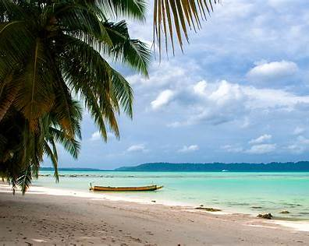
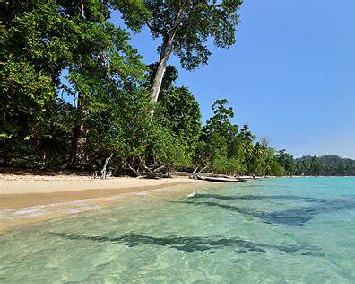
Light & Sound Show
The Sound and Light show in the Cellular Jail narrates the saga of the Indian freedom struggle, brought alive through the sound and light effect of the brutal and barbaric atrocities piled on the freedom fighters deported to these islands and incarcerated in the small cells of this jail. This show is very popular among the tourists visiting these islands.

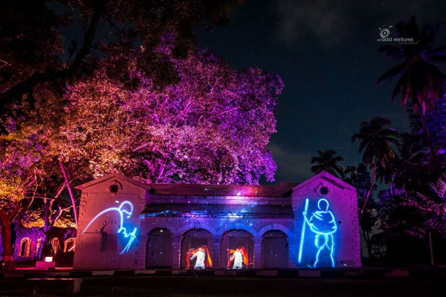
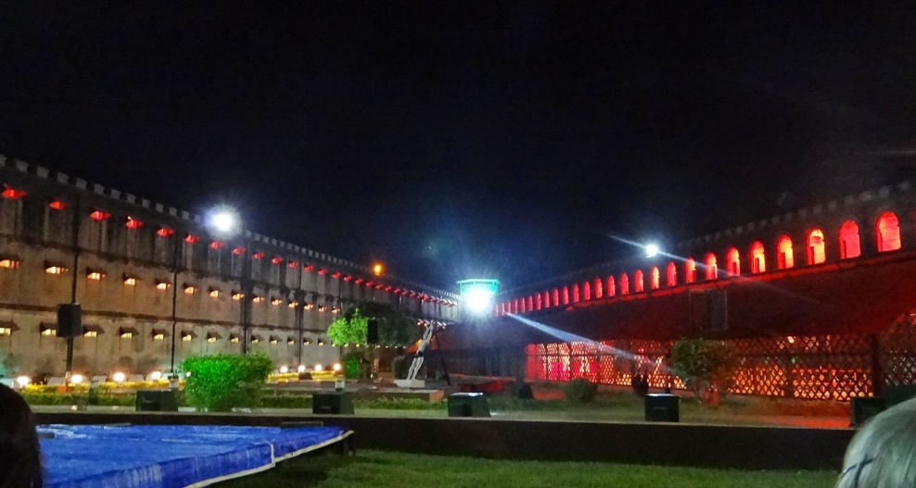

• Cellular Jail
mute witness to the most brutal and barbaric atrocities meted out to national freedom fighters, who were incarcerated in this jail. The jail, completed in the year 1906 acquired the name ‘Cellular' because it was entirely made up of individual cells for solitary confinement. It originally was a seven-block structure with three stories and a central tower acting as its fulcrum consisting of honeycomb-like corridors. This jail, now a place of pilgrimage for all freedom-loving people draws everyone down memory lane to the years of freedom struggle. The Jail Museum is open from 9:00 am to 12:00 noon and from 1:30 pm to 4:45 pm.
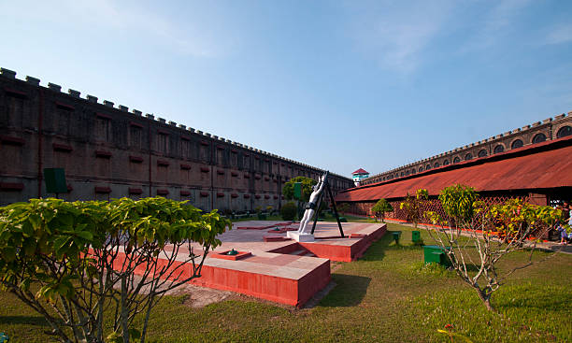
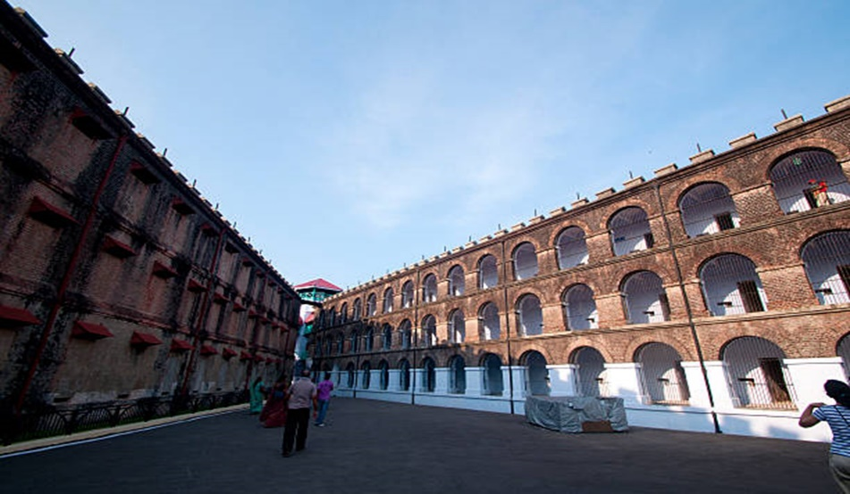

Day 2: Port Blair to Excursion to Coral island & Ross Island :
After Breakfast you will be escorted to Andaman Water Sports Complex to catch a ferry which will be your mate for the entire excursion to Ross Island and North Bay. Overnight stay at Port Blair.
• North Bay
It is also called “The GateWay to Port Blair”. This place is famous for its coral reefs, exotic verities’ of beautiful ornamental fishes and water sports activities. The breathtaking stretch of coral bed leaves you spellbound. North Bay is the foremost snorkeling point of Andaman. Apart from snorkeling and glass-bottom boat ride, scuba diving, underwater sea walk facility is also available at North Bay.
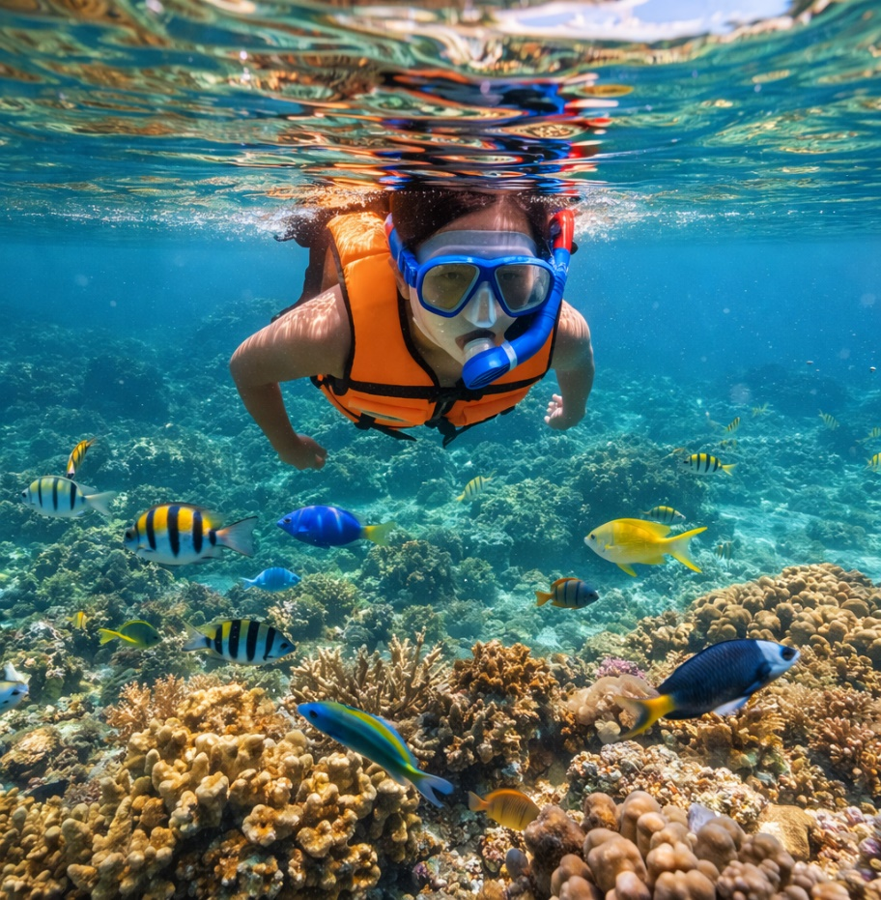
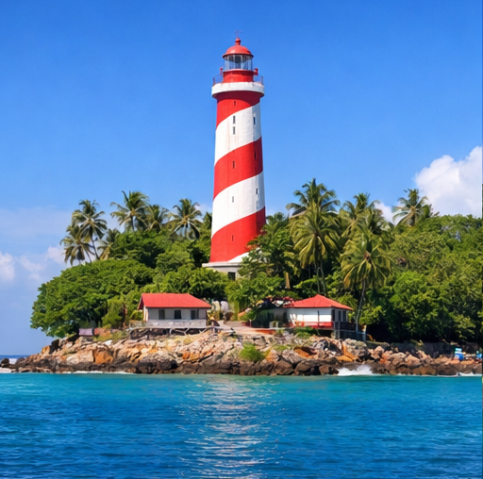

• Ross Island
It was the Capital of Port Blair during the British and Japanese regime, prior to India’s Independence. It was named after Sir Daniel Ross, a marine surveyor. It was nicknamed “The Paris of the East”. It is now under the supervision of the Indian Navy. This island is an ideal destination for nature walks amidst sylvan surroundings with deer’s, peacocks and exotic birds. • Ross Island
It was the Capital of Port Blair during the British and Japanese regime, prior to India’s Independence. It was named after Sir Daniel Ross, a marine surveyor. It was nicknamed “The Paris of the East”. It is now under the supervision of the Indian Navy. This island is an ideal destination for nature walks amidst sylvan surroundings with deer’s, peacocks and exotic birds.
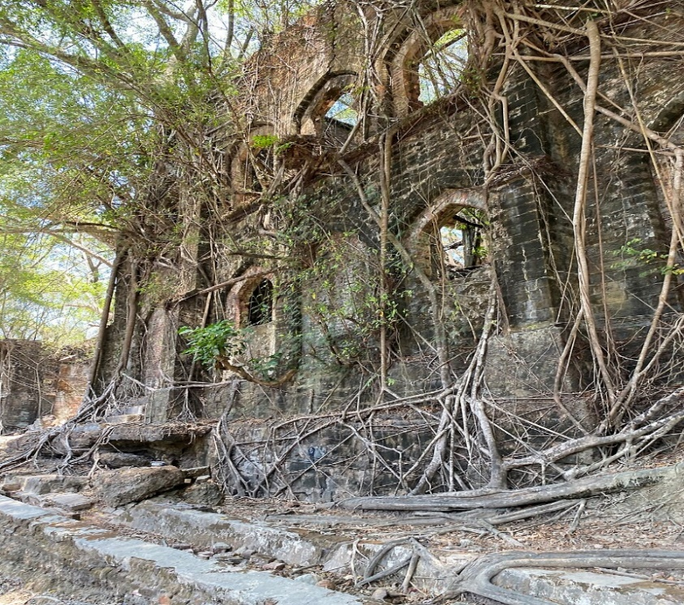
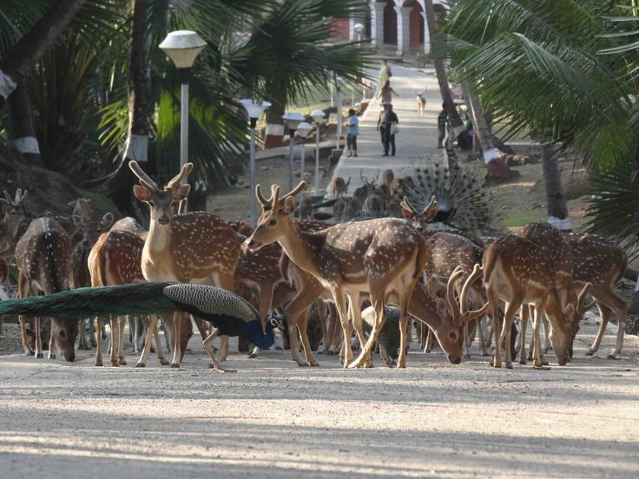

Day 03: Port Blair - Swaraj Dweep Island (Havelock) - Radhanagar Beach:

Transfer to Swaraj Dweep (Havelock Island) by Cruise. On arrival, our representative will receive you from Havelock Jetty and escort you to check-in to the selected hotel. After a little relaxation, proceed to the world’s most renowned beach; Radhanagar Beach. Overnight stay at Havelock.
• Radhanagar Beach
The Island (often just called Havelock) is one of the most beautiful and largest islands of Ritchie's Archipelago and is a placid heaven like no other. Situated 57 km northeast of the South Andaman with an area of 92 Sq.Kms she offers a breathtaking trail of nature expeditions. The island is primarily populated by Bengali settlers. This picturesque Island with beautiful sandy beaches and lush green forest is also rated as the seventh most beautiful island in the world. The Island also has the biggest concentration of breath-taking diving and snorkeling sites, thus acting as a paradise to marine world explorers.
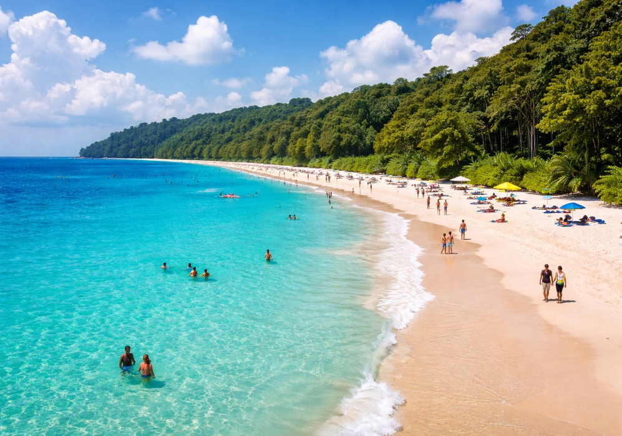
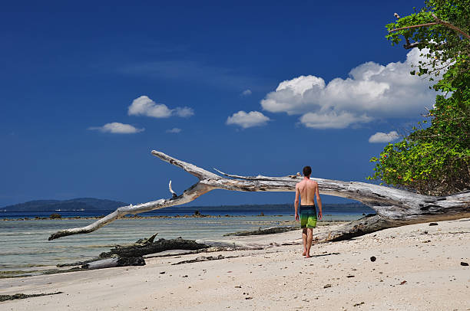

Note: Collect the packed Breakfast from the hotel reception, if you are traveling by early morning Cruise. Ferry timings are mentioned in the tickets provided to you, please report 45 minutes prior to departure with a valid id card. Ferry operation is purely subject to Govt. clearance and weather conditions. Class of travel and timings of the ferry is subject to availability at the time of confirmation.

Day 04: Swaraj Dweep (Havelock Island) – Shaheed Dweep (Neil Island)
In the morning, have your breakfast in the hotel after that our representative will help you to board the Boat which will sail to the Shaheed Dweep (Neil Island Island). On arrival at Neil Island, our representative will receive and escort you to check-in to the resort/hotel. After that start a trip for sightseeing in Laxmanpur, Bharatpur & Howrah Bridge. Overnight stay at Neil Island.
• Bharatpur BeachBharatpur Beach is a beach of a low tide located just half a kilometer from the jetty, considered to be the best beach on Neil Island. The calm, tranquil, and perchance of the picturesque beach is also popular with various water activities like swimming, snorkeling, and scuba d
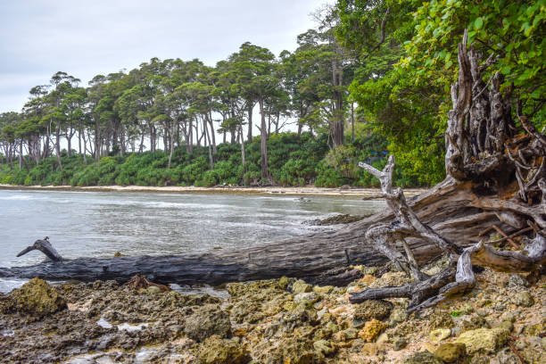
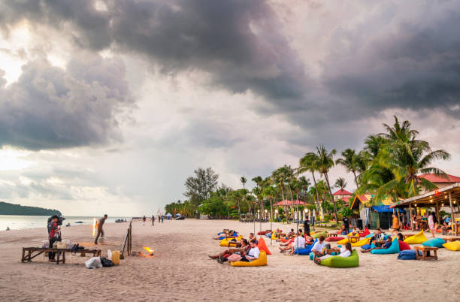

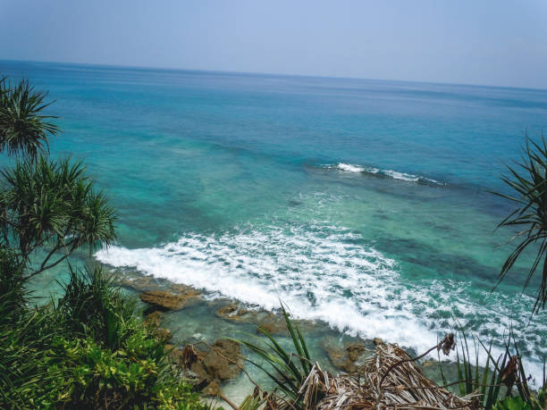
• Laxmanpur BeachLaxmanpur Beach is a picturesque waterfront, covering a long stretch of the area of Laxmanpur village of Neil Island. The sea is shallow and calm, making it perfect for swimming and snorkeling. The serene beach offers a stunning panorama, especially the sun sets in the horizon.

• Natural Bridge
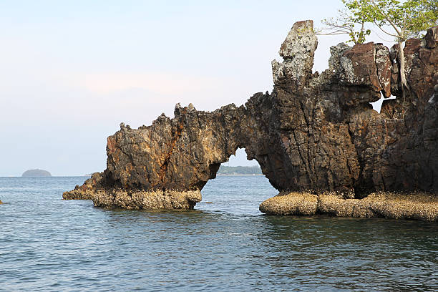
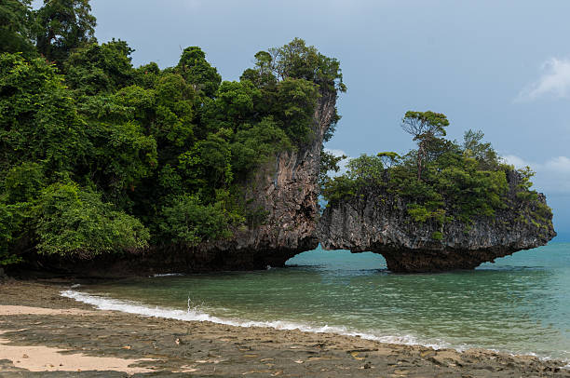
Neil Island is famous for its naturally shaped- like rock also known as the Howrah Bridge. It has two living natural corals formed just like a bridge. The rock formation was called by the Bengalis who settled in the island in the early days and they refer to it as the Rabindra Setu and later called it the Howrah Bridge. It is best seen during low tide.

Day 05: Shaheed Dweep (Neil Island) - Port Blair.
After breakfast, board Green Ocean Cruise / Makruzz and return to Port Blair. Evening free for local marketing. Overnight stay at Port Blair

Day 06: Port Blair – Airport Dropping
Dropping to the airport with memories and terrific holiday at Andaman Islands.
Note: If your departure flight is a delay, the additional tour will be arranged on a direct payment basis.

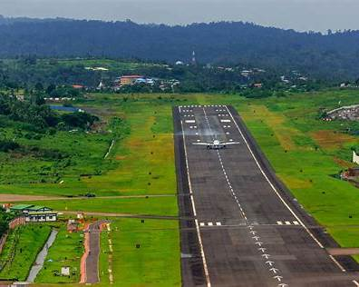
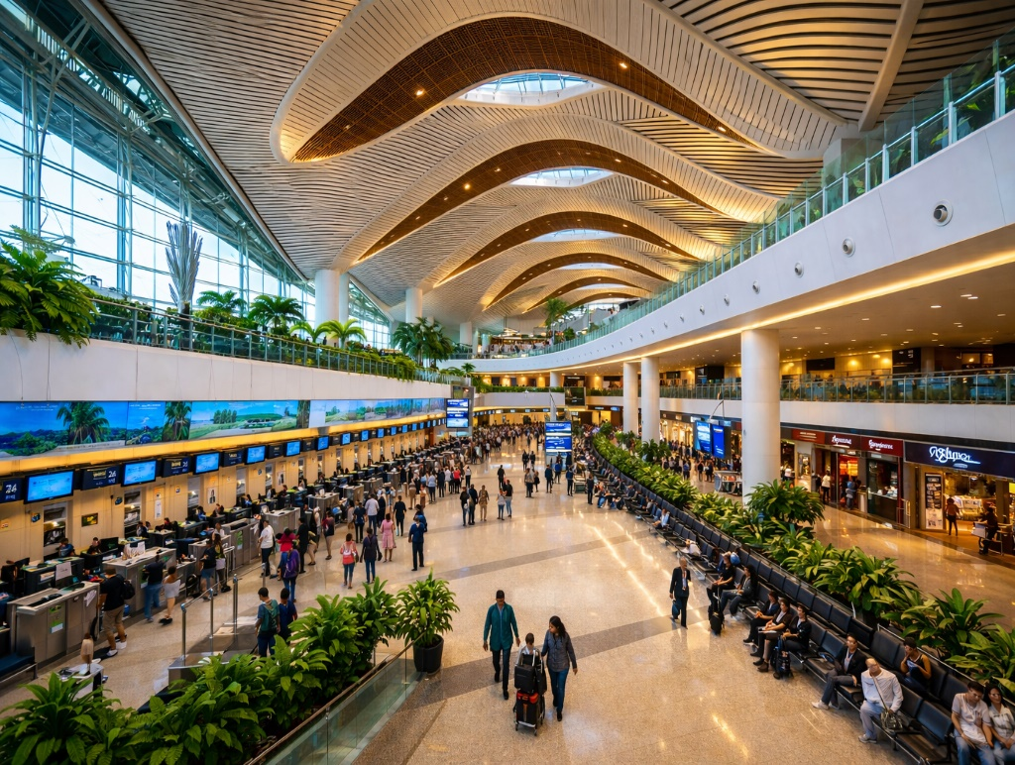
Dropping to the airport with memories and a terrific holiday at the Andaman Islands
Note: If your departure flight is delayed, the additional tour will be arranged on a direct payment basis.

Package Includes :
Accommodation on a double sharing basis at the above-mentioned hotels / similar in base category rooms.
Exclusive a/c vehicle sanitized every time before boarding for pick up and drop as per the itinerary (not at disposal).
Daily breakfast Only.
Airport pick up and drop by a/c vehicle.
Makruzz / Green Ocean Cruise / Sea Link / ITT Majestic (base category) for Neil & Havelock as per the availability.
Assistance at all arrival and departure points.
Entry permits | Entry tickets | Parking charges | Boat/ferry tickets wherever applicable.

Package Excludes :
Airfare / Ship's fare.
All kinds of personal expenses such as tips, laundry, telephone bills and beverages.
It does not include any meals unless and otherwise specifically mentioned.
Guide, Jolly ride & snorkeling charges.
Optional, suggested or unspecified activities.
Guide at Cellular jail will cost extra.
Camera fee (still or movie)
Additional usage of vehicles.
Any dispute regarding the child's age is to be settled directly with the hotels.
 GST (5%) if bill required.
Please find below the optional rates for various water activities Havelock Island:

Note :

 The above is just a quote, no rooms have been blocked. Rooms are subject to availability at the time of confirmation.
Since the Union Territory of Andaman and Nicobar is under the restricted area category, please carry a valid photo identity proof for all travelers issued by competent authorities.
Our representative will hold the placard outside the exit gate of the Airport.
Check-out time at most of the hotels in Port Blair / Havelock / Neil Island is 0900 hrs. Late check-out as per availability only, although guaranteed check-out is possible by paying 50% of the room charges.
Issues regarding child age to be settled with hotels directly.
We do not book any of our guests to Havelock / Neil in govt. ferry, until and unless there is an emergency or disruption, we may shift the guest to govt. ferry to Havelock & and Neil Island.

Important Travel Tips to protect yourself and others during Covid-19:
The use of a facemask is mandatory.
Maintain a distance of 6 feet (2 meters) between you and others as much as possible.
Keep hand sanitizer and use it on a regular basis.
Avoid touching your eyes, nose, and mouth.
All guests must mandatorily have the Aarogya Setu Mobile application installed and used frequently.
Use hand gloves whenever traveling by ferry/cruise or any crowded area.
Maintain hygiene standards.

